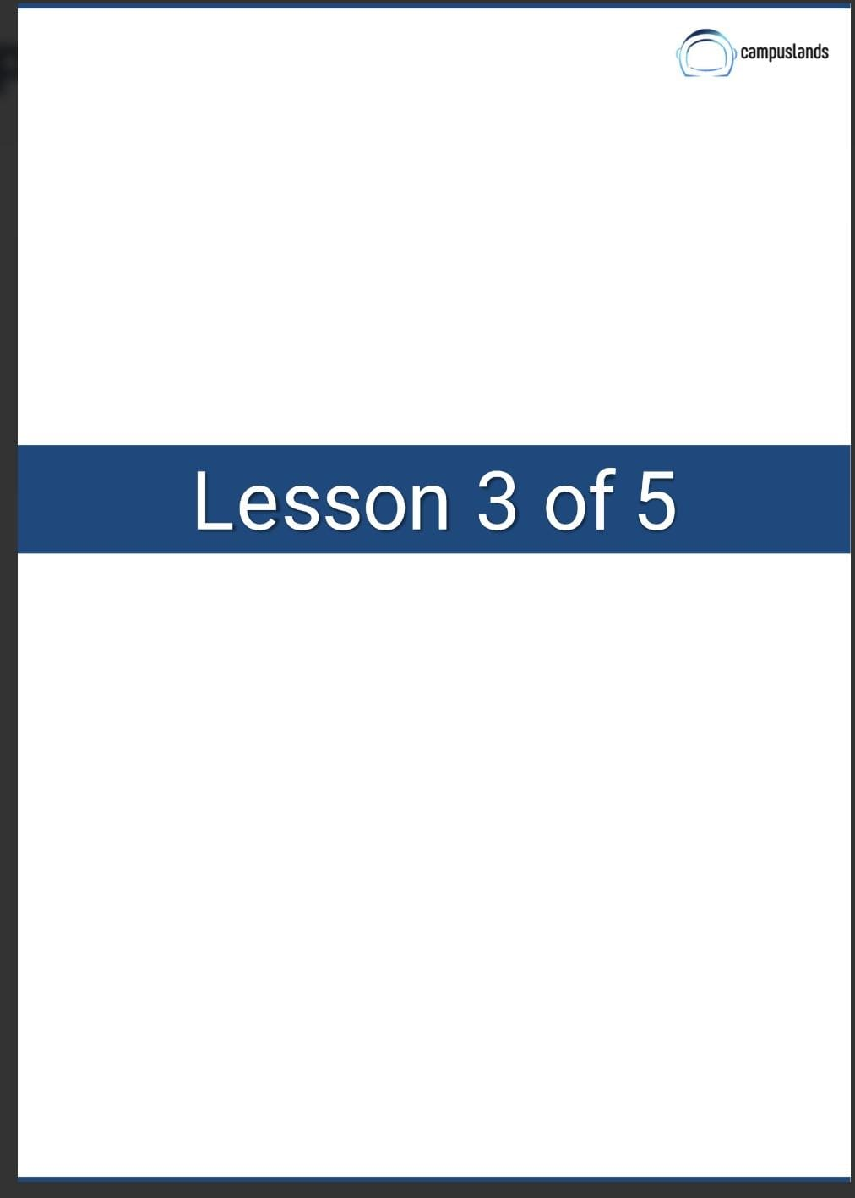
Pamela Michell Galvis Alvarez
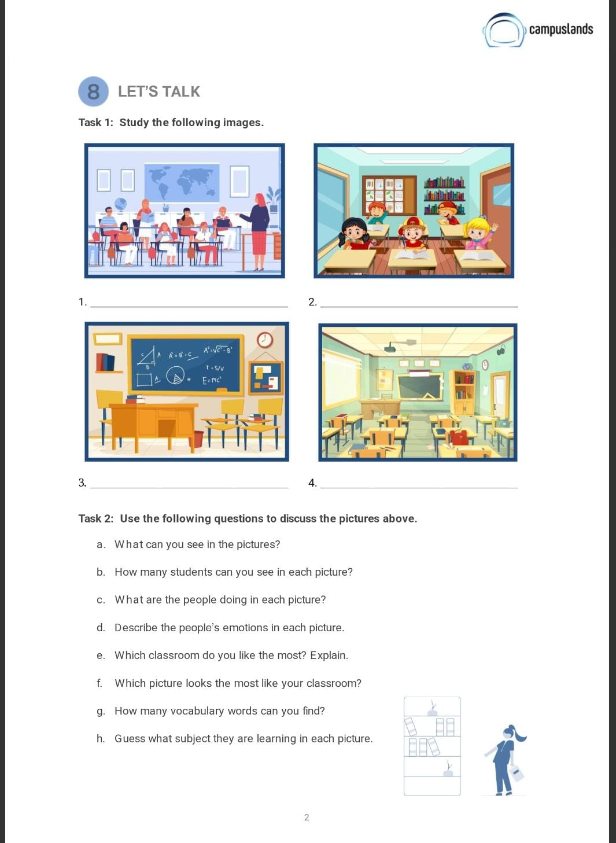
resolution of activities
A Lively Classroom Session
Happy Students in a Bright Classroom
The Mathematics Classroom
An Empty and Tidy Classroom

a. What can you see in the pictures?
In the pictures, I can see various classrooms. Some are empty, and some have students and teachers. There are desks, chairs, whiteboards/blackboards, books, and other classroom items.

b. How many students can you see in each picture?
1. Picture 1: I can count approximately 7 students.
2. Picture 2: I can count 5 students.
3. Picture 3: 0 students (the classroom is empty).
4. Picture 4: 0 students (the classroom is empty).

c. What are the people doing in each picture?
1. Picture 1: Students are sitting at desks, listening to the teacher who is standing at the front of the classroom, possibly giving a lesson.
2. Picture 2: Students are sitting at their desks, smiling and looking engaged, possibly listening or about to begin an activity.
3. Picture 3: There are no people in this picture.
4. Picture 4: There are no people in this picture.

d. Describe the people's emotions in each picture.
1. Picture 1: The students appear attentive and focused. The teacher seems to be teaching.
2. Picture 2: The students look happy, cheerful, and possibly excited or engaged.
3. Picture 3: N/A (no people).
4. Picture 4: N/A (no people).

e. Which classroom looks do you like the most? Explain.
I like the classroom in Picture 2 the most. It looks bright, colorful, and the students seem very happy and engaged, which suggests a positive learning environment. The classroom in Picture 1 also looks good, but Picture 2 has a more cheerful vibe.

f. Which picture looks the most like your classroom?
Picture 1 looks the most like my classroom because we have desks arranged in rows, a whiteboard at the front, and a teacher leading the class.

g. How many vocabulary words can you find?
Let's list some:
* classroom
* students
* teacher
* desks
* chairs
* whiteboard / blackboard
* books
* map (in picture 1)
* shelves / bookshelf (in pictures 1, 2, 3)
* globe (in picture 1)
* clock (in picture 3)
* door
* window

h. Guess what subject they are learning in each picture.
1. Picture 1: Given the world map on the wall and the general setup, they could be learning Geography, Social Studies, or History.
2. Picture 2: It's harder to tell without specific clues, but it looks like a general primary school classroom, so it could be Math, Reading, or General Studies.
3. Picture 3: There are mathematical equations on the blackboard, so this classroom is set up for Mathematics or Physics.
4. Picture 4: This classroom is quite generic, so it could be for any subject, like General Studies, Language Arts, or even a specialized subject depending on the specific equipment which isn't clearly visible.

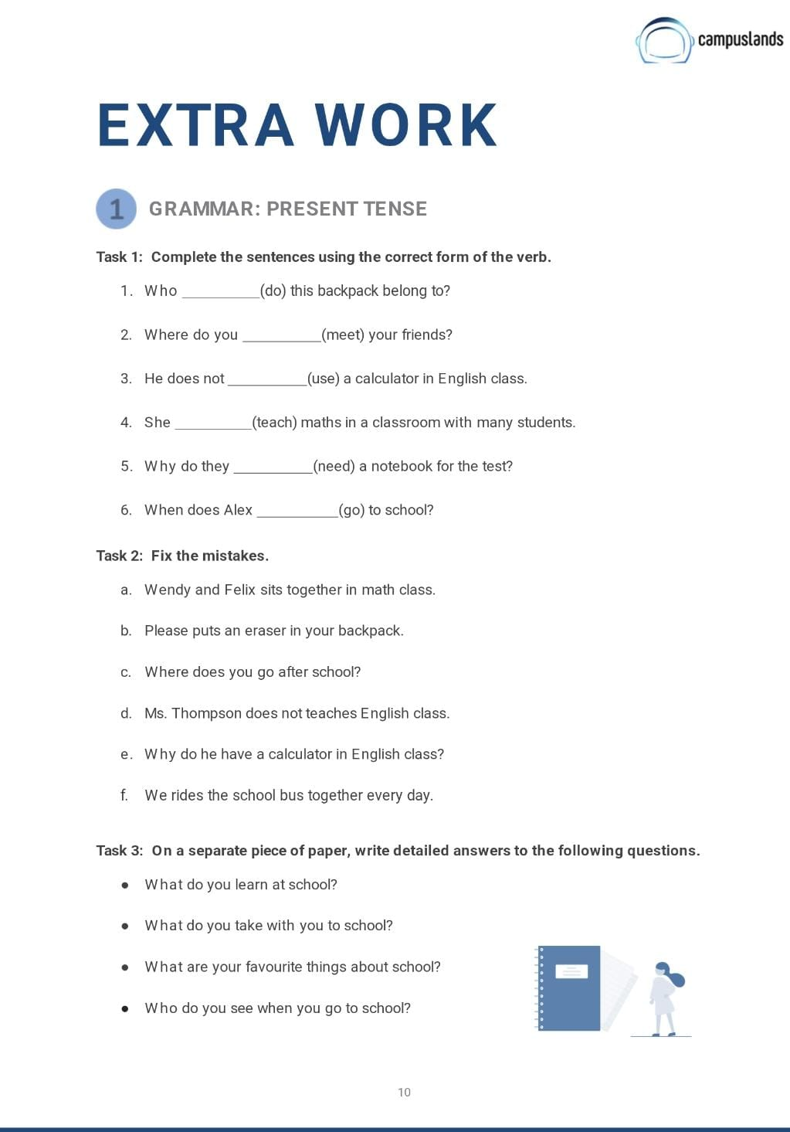
meet
does
use
teaches
need
go
Wendy and Felix sit together in math class.
Please put an eraser in your backpack.
Where do you go after school?
Ms. Thompson does not teach English class.
Why does he have a calculator in English class?
We ride the school bus together every day.
- What do you learn at school?
- At school, I learn many different subjects. For example, I learn Mathematics to solve problems and understand numbers. I study English to improve my communication skills and learn about different cultures. I also learn about Science to understand the world around me, and Social Studies/History to learn about the past and how societies work. Besides academic subjects, I learn important life skills like teamwork, critical thinking, and how to manage my time.
- What do you take with you to school?
- When I go to school, I always take my backpack. Inside, I carry my textbooks and notebooks for each subject, a pencil case with pens, pencils, and an eraser. I also bring my water bottle to stay hydrated and sometimes a snack or my lunchbox. If I have a specific project, I might bring a laptop or other materials.
- What are your favourite things about school?
- My favourite things about school are definitely learning new things and seeing my friends. I enjoy the challenge of understanding new concepts in subjects like science or history. It's also great to spend time with my classmates, collaborate on projects, and share laughs during breaks. I also appreciate the teachers who make learning interesting and help us grow.
- Who do you see when you go to school?
- When I go to school, I see a lot of people! First, I see my teachers who guide us through our lessons. I see all my classmates and friends from different grades. I also see the principal and other staff members who work in the school office or in the cafeteria. Sometimes, I even see parents dropping off or picking up students.

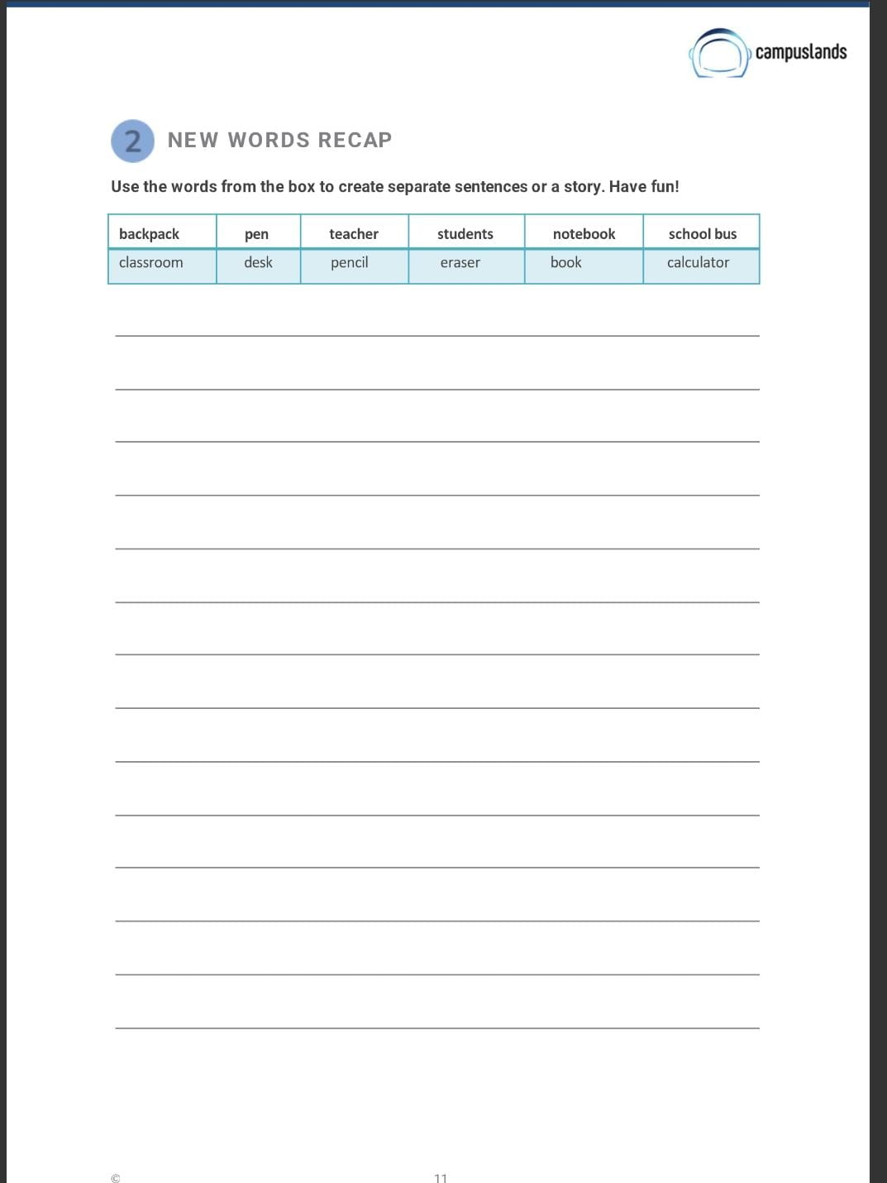
1. My new backpack is blue and has many pockets.
2. I use a pen to write important notes in my notebook.
3. Our teacher explains difficult topics very clearly.
4. The students in my class are very friendly and collaborative.
5. I always keep my notebook organized for every subject.
6. The school bus picks me up at 7:30 AM every morning.
7. The classroom is bright and has many colorful posters.
8. My desk is a bit messy, but I know where everything is.
9. I need a pencil to draw maps in geography class.
10. I use an eraser when I make a mistake while writing.
11. My favorite book is about a magical adventure.
12. We use a calculator for complex problems in math class.

